

**Kalasalingam College of Nursing**

**Lab Facilities**

**Nursing Foundation Lab**

The Basic nursing skills are taught and learned in this lab. If this lab is well equipped with various types of mannequins simulator and essential articles in advanced nursing procedures such as ECG, CPR, airway management. So, that the students get oriented with the various innovative nursing care. The novice students get opportunities to develop the skill in basic nursing care and gain confidence before they implement the patient care in the Hospitals.

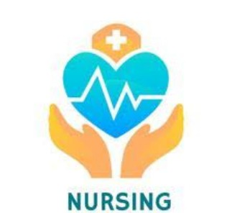

**Maternal and Child Health Nursing Lab**

The MCH lab helps the students to acquire knowledge and hands on training in mother and new born care that are to be practiced in clinical settings. The MCH lab is equipped with maternity examination model, gynecological examination model, delivery model, charts and other equipment. MCH lab provides a learning atmosphere to the students for developing skills before performing procedures in the hospital. It helps the students able to prepare sterile trays like perineal care tray, suture removal tray, forceps delivery tray, vaginal examination tray and surgical trolley.

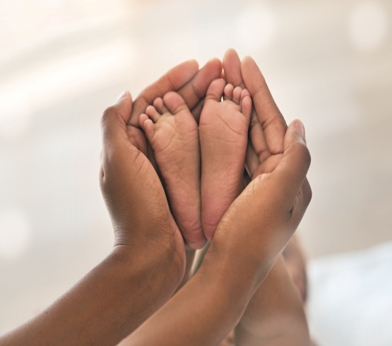 

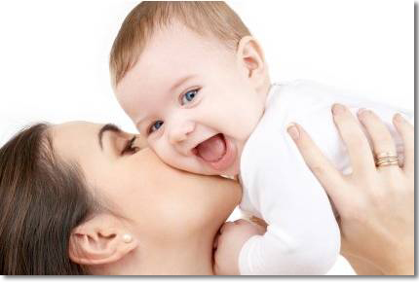

**Community Health Nursing Lab**

This lab facilitates the nursing students to gain the experience in family care activities, basic principles of preparing and utilizing the IEC materials such as flash cards, flip charts, flannel board, puppets, Hand outs, leaf let, Charts, posters and also comprisal the articles required for Home visiting and activities. This lab is spacious and well organized, so that they can do the works for community oriented projects, Role play, mass awareness programme, exhibitions etc. The details of each family care activities are maintained in the Records which are stored according to the ward or area.



**Audio Visual Lab**

Audio Visual aids play a vital role in modern education. A good collection of Audio Visuals Aids like OHP slide projector, LCD projector, Audio Video players, still and working models etc. are there in this lab.

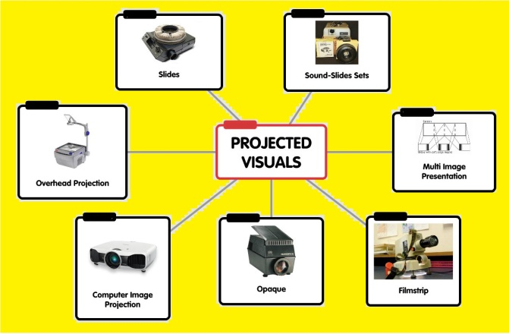

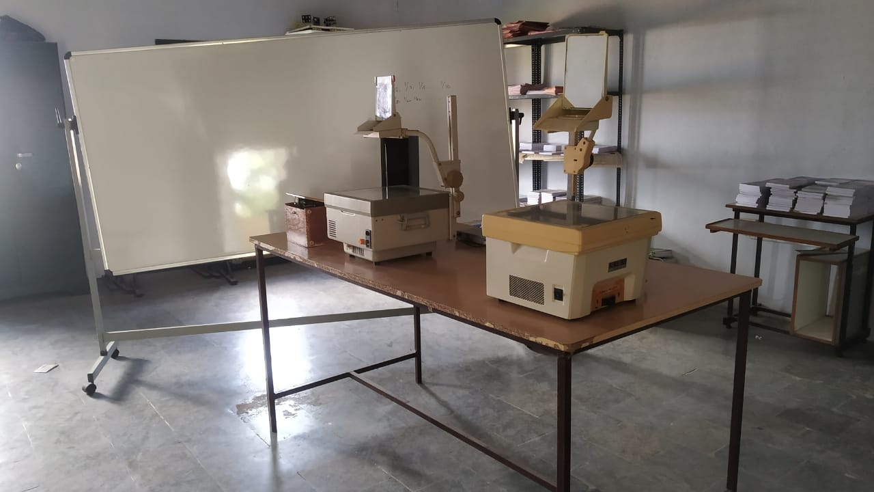

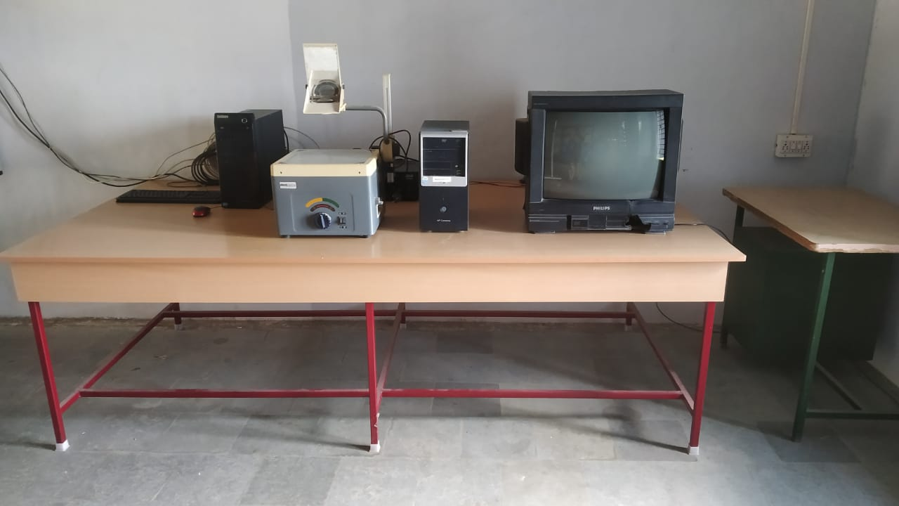

**Nutrition Lab**

The college has a well equipped nutrition lab  to provide practical knowledge of how to plan diet keeping in mind the patient needs and requirements. The students are taught to plan the menu scientifically, based on the calorific value of the food materials.

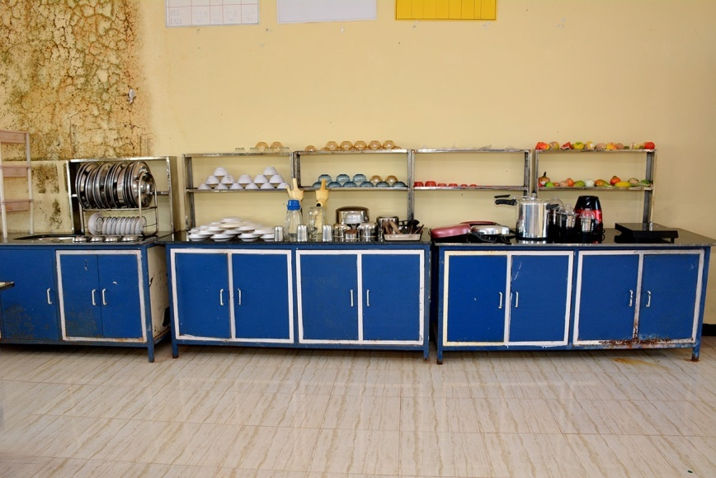

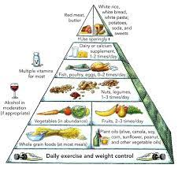

**Computer Lab**

**KARE** has more than 50 Computer labs with 2500+ computers across different departments. An exclusive common computing facility is also available for students and faculty. A 3 GBPS internet connection is available connecting all computers providing internet access to all Systems.

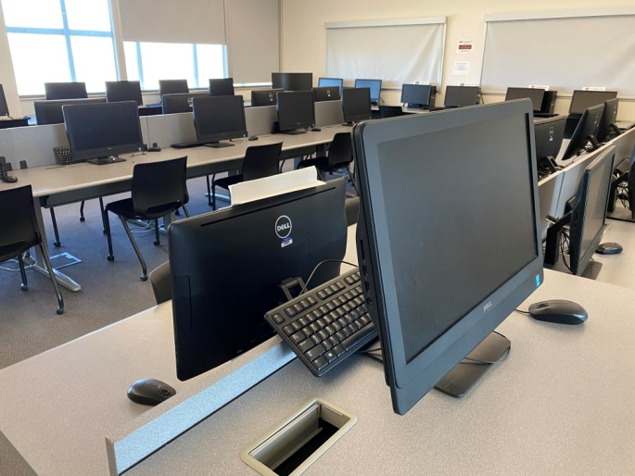

**Pre Clinical Labs**

The anatomy and physiology lab consist of all the equipment such as adult human articulated skeleton, adult skull, pelvic, heart with large blood vessels, eye with different section, ear with different section, full set of disarticulated adult human skeleton, and different charts of all the systems. The lab is well furnished in such a way that the students are able to acquire their knowledge through their different demonstration.

